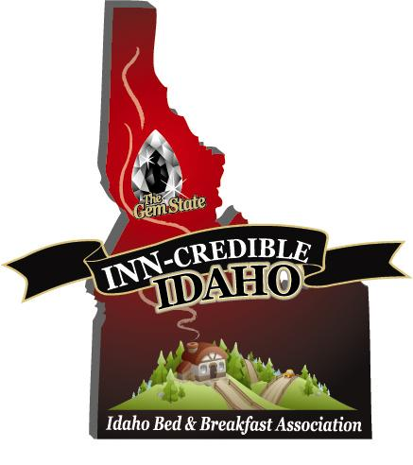

Newsletter #10 August 26, 2011

Wow! We knew that if you gave this association and its’ website, www.idahobba.com 18 months, great things would start to happen. We have heard from lodging members in Sandpoint, Coeur d’Alene, Moscow, Cottonwood, Albion, Pierce, White Bird, Boise, Caldwell, Cascade, Preston, Ririe, and Salmon, that reservations/phone calls as a direct result of the website, are starting to take place. And--- that information is only from the members who took the time to call and let us know. We can only look for bigger and better seasons now that we received our grant monies to start the website SEO, and other elements.
Now, let me reiterate that the IBBA website, www.idahobba.com is MOST valuable if it is fully utilized by all of its members. When you first joined, some basic details were added to the IBBA website for your business. However, to take full advantage of what the site can offer, and to best showcase your facility, you should login and update your details. If you have never done so, we encourage you to login and showcase your business!
To edit your listing, add details, upload images, and check for accuracy follow these instructions:
- Login to the IBBA website at http://idahobba.com/innkeeper-login.html.
- To start updating your information click the Edit Your Listing link from the User Menu.
- You will be taken to a display of your basic information. Click the “Edit link” displayed at the lower left of your listing.
- Listing changes are not instantly added to the directory, but will first be reviewed and approved by the IBBA Board.
- Please limit the Short Summary to 50 words or less, and the Long Description to 500 words or less. Our aim is to provide basic information and to direct visitor's to your site
- The Listing form is quite long, but it is important to complete the information with as much detail as possible. If you need to stop during the process just submit the listing and come back to it later.
- You may add up to 5 images. To keep the site consistent, please DO NOT add images with borders, text or logos.
- Be sure to Submit before exiting the form page or you will lose your changes.
If you have difficulty or need assistance, contact Mary Kendall at webmaster@idahobba. Or call her at (509) 292-0841.
Survey Results: Thanks to the members that responded to the survey. The results were overwhelmingly in favor of the SEO for the website, followed by the creation of a brochure and 2012 IBBA Convention linked with ICORT
Welcome our 4 New Members: For a complete list please see the attachment.
From the Northern Region: Sweet Magnolia B&B in Sandpoint
In the Southeast Region: Abigails B&B in Malad City and Rocky Mtn. Red Brick Inn, in Preston
From the Southwestern Region: Wapiti Meadow Ranch inCascade
Don’t forget our wonderful vendor partners:
Tax Consultant specializing in small lodging tax preparation
Insurance Services
Association Alliance
Credit Card Processing
Propane Services @ small business owner discounted pricing

(If you are a member, you can access these vendor partners from the website after logging in on the membership page.) Using any of the partners services will more than pay for your association dues. You will also have access to our partners by becoming a member. By now, I hope all of our members have been contacted by our Association endorsed credit card processing company.
Our newest business partner specializes in providing propane services to small business owners throughout the state. We are contacting businesses throughout the state that you refer your guests to. Please don’t hesitate to call or email me with some of your favorites! We hope they will become travel partners or business vendors.

PAII: Through a special arrangement with the Professional Association of Innkeepers International, (PAII), we are able to obtain a substantial discount for a dual membership package. This has been offered to our members for only $79. For those of you who have not joined IBBA, you can join both for $144. IBBA will subsidize this dual membership by contributing $10 for all that choose to join. Dual membership in both associations can only be a win-win for our members. For those of you that are already members of IBBA that would like to join PAII, you may simply send us your check, made out to IBBA for $69 and IBBA will subsidize the additional $10 for you also.

Save the Dates for our Annual Convention: The Idaho Conference on Recreation and Tourism has offered to hold our annual convention within the state conference in May 8,9 & 10 of 2012. It is the 20th anniversary of Idaho Travel Council, and will be held here in Coeur d’Alene, at the Coeur d’Alene Resort and Convention Center. We are very excited about this unique opportunity, and hope to make this joint conference the best ever! More information will be available on the website soon.

Going Green: If you are an environmentally friendly lodging facility and would like to be included in our new going green program, check it out on the IBBA website.

Inns For Sale: A free bonus feature now available with your membership is the inns for sale section of the website. Log in as a member and proceed to the “Trip Planner” page and you will see the “Inns For Sale” box in the lower right hand corner. Simply click on the box and follow the instructions to submit your listing. (Don’t forget to submit). This feature is another example of what your $75 membership can do for you! Those of you with inns for sale, who are not currently members of IBBA, this is a great advertising opportunity with membership.

Second Lodging Category Listings: If you have a specific and/or different type of lodging, for example along with your main lodge, you also have a cabin, yurt, cottage or tent cabin, you may choose to show those cabins etc., under a second listing for $25. This second listing gives your potential guests another avenue to search for your unique lodging.

Hot Leads Program: The association will be eliminating this program at the end of August as the small amount of funding from last year’s grant will have been depleted.

Join our great association! Our Association holds a large umbrella because we include Guest Ranches; Tent Cabins; Dude Ranches; Traditional B&B’s; Country Inns; Cottages; Guest Houses & Farm Stays. We would like to encourage all of you who are not yet members of our state Association to join, and get your business advertised on our website! Send your check, $75, made out to IBBA, to the address below or pay on line through paypal. We welcome your involvement as we continue to grow and meet the challenges ahead!

Brian Scott, President & Sharlene Scott, Secretary/ Grant Administrator
705 S. Zircon Lane
Coeur d’Alene, ID 83814
208-664-9650
info@idahobba.com

