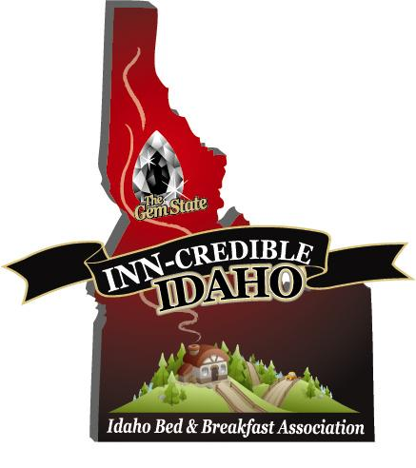

Newsletter #13 June 2012
Hello from the Idaho B&B Association

Hello
I would like to welcome you to the #13 IBBA Newsletter. Let's start right in with some exciting news/results of the ICORT conference held here in Coeur d'Alene in May. Our presentation to the Idaho Travel Council requesting funding for 2012-13 was a hit, and in the words of Diane Newman, ICORT Council Member from the South Central Region, "You have hit a Grand Slam
with your presentation and with the new IBBA brochure!" At the conclusion of the presentation, the Idaho B&B Association was presented with a ribbon and certificate awarding us for designing and producing the top brochure for grant recipients in the state of Idaho. Please contact me if you would like to have some of these brochures sent to you to display in your B&B.
Brian Scott, IBBA President

Don't forget our wonderful business vendor partners! We are very happy to welcome two new preferred vendor partners to the Association.
- Deneen Pottery 1-888-646-0238 Making Stoneware pieces on the potter's wheel since 1972. They take great pride in creating perfect forms that can be customized with logos and artwork along with flawless detail.
- Comphy Sheets 1-323-225-8234 Shantell Denson is our contact for this wonderful company that caters to innkeepers and spas. The sheets look and feel like 600 count cotton, but are made from Eco-friendly micro-fiber.

(If you are a member, you can access these vendor partners from the IBBA website after logging in on the membership page.) Using any of the partners services will more than pay for your association dues. You will also have access to our partners by becoming a member. By now, I hope all of our members have been contacted by our Association endorsed credit card processing company.
We are contacting businesses throughout the state that you refer your guests to. Please don't hesitate to call or email me with some of your favorites! We hope they will become travel partners or business vendors.

IBBA Inn-Spirational Innkeeper "Bonzey"Award
Jay Karen, President and CEO of PAII, presented Ruth May, Innkeeper of Reflections Inn in Kooskia Idaho, with the annual Inn-spirational Innkeeper Award at the ICORT conference in May. Ruth was among several nominees for this year's award. Having Jay available to present this award, made this portion of the luncheon a big hit! An excerpt of the presentation can be found below:

"Seventeen years ago, an energetic couple found themselves on the upper portion of the Clearwater River surrounded by forest, and turned a rustic sportsman's hangout into a beautiful & serene bed & breakfast inn that attracts visitors from far & wide.

Also noteworthy has been their 17 year commitment to not only the Inn, but also the economic viability of the area, through their community involvement & long-range vision.

They are good industry partners realizing success involves more than guests entering their inn. They share their vast knowledge of the area's history, and match their guests with appropriate activities and experiences while in Idaho. If that means referrals to other inns or businesses, they are most generous to do so.

They also wholeheartedly believe in the value of industry involvement via the Idaho Bed and Breakfast Association, the Professional Association of Innkeepers International, and Idaho Tourism in all its facets."

Great News Regarding our IBBA Website:
Inside Out Solutions wanted to update you briefly about the performance of our website's SEO service now that we have a substantial amount of comparative data. The following stats compare Apr 1 through Jun 25, 2012 to the same dates in 2011
- Visits quantity via organic (i.e. non-paid) search engine query results are up dramatically at 132.14% (1,365 vs 588)
- Visit quality is down only moderately; this is typical for the substantial increase in search engine visibility and traffic
  - Pages/Visit are down 26.15% (4.52 vs 6.12 pages)
  - Bounce Rate (visitor leaves from the landingpage) is up 36.45% (44.32% vs 32.48%)
- Visits via Google are up 138.46% with a moderate decrease in visit quality
- Visits via Bing are up 168.42% with a moderate decrease in visit quality
- Visits via Yahoo are up 75.61% with a moderate decrease in visit quality.
- The number of keyword phrases entered into search resulting in visits increased dramatically at 210% (563 vs 268) and the actual number of phrases is likely higher than that because Google started hiding the keywords of its registered, logged-in users in late 2011. This "horizontal growth" (visits from a greater number of search keywords) is also true in the vertical axis (i.e. more visits for the same term)

PAII Reduced Rates:
Don't Miss Out! Through a special arrangement with the Professional Association of Innkeepers International, (PAII), we are able to continue our substantial discount for a dual membership package. This has been offered to our members for only $79. For those of you who have not joined IBBA, you can join both for $144. IBBA will subsidize this dual membership by contributing $10 for all that choose to join. Dual membership in both associations can only be a win-win for our members. For those of you that are already members of IBBA that would like to join PAII, you may simply send us your check, made out to IBBA for $69 and IBBA will subsidize the additional $10 for you.

To All Prospective Members:

Our association represents small lodging throughout the state of Idaho. Along with our Traditional B&B's, we also represent Cottages, Country & Historic Inns, Guest Ranches, Cabins, Farm Stays, Tent Cabins & Yurts. We invite you to become a member. Remember, your $75 membership gives you access to all of our preferred vendors, inclusion in the brochure, featured listing on the website and our newest member benefit, inclusion of a location icon placed on the travel show map. Please email us at info@idahobba.com

Brian Scott, President & Sharlene Scott, Secretary/ Grant Administrator
705 S. Zircon Lane
Coeur d’Alene, ID 83814
208-664-9650 Toll Free: 877-664-9650
info@americancountrybedandbreakfast.com
www.americancountrybedandbreakfast.com

